**Using ELMAH for Logging Error Details**

ELMAH is an approach to logging runtime errors in a production environment. ELMAH Error Logging Modules and Handlers is a free, open source error logging library that includes features like error filtering and the also the ability to view the error log from a web page, as an RSS feed, or to download it as a comma-delimited file. The main advantage of ELMAH is it's pluggable feature. You can easily integrate the ELMAH component in your application. It's an open source project and you can customize the code according to your needs. You can also store the error information in Sql server, Oracle, Access or XML.

**Adding ELMAH to an ASP.NET Web Application**

Step 1: Getting the ELMAH Project Files and Adding Elmah.dll To Your Web Application

You may visit the [ELMAH website](http://code.google.com/p/elmah/) to get the latest version or to download the source code. Extract the ELMAH download to a folder on your desktop and locate the ELMAH assembly file (Elmah.dll).or if you are using mvc we may get it using NuGet package manager library. Add the reference of the Elmah to the project in mvc there are two dll which is used for error logging Elmah and Elmah.mvc.

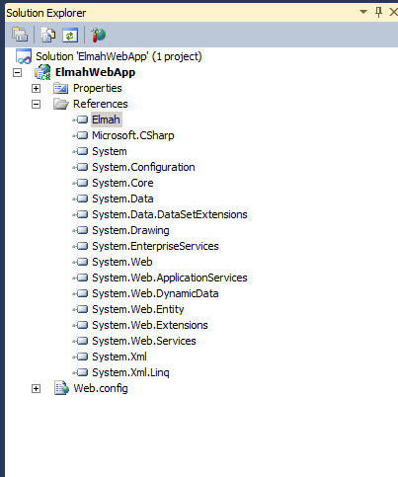

The Elmah.dll assembly contains the classes used by the ELMAH system. These classes fall into one of three categories:

* **HTTP Modules** – It is a class that defines event handlers for HttpApplication events, such as the Error event. ELMAH contains multiple HTTP Modules, the three most germane ones being:
  + **ErrorLogModule** - logs unhandled exceptions to a log source.
  + **ErrorMailModule** - sends the details of an unhandled exception in an e-mail message.
  + **ErrorFilterModule** –this module applies developer-specified filters to find out what exceptions are logged and what ones are ignored.
* **HTTP Handlers** – This is a class that is responsible for generating the markup for a particular type of request. ELMAH contains HTTP Handlers that render error details as a web page, as an RSS feed, or as a comma-delimited file (CSV).
* **Error Log Sources** – Another advantage is that ELMAH can log errors to memory, to a Microsoft SQL Server database, to Access database, to an XML file, to an Oracle database, to a SQLite database, or to a Vista DB database. You can create and simultaneously integrate your own custom log source providers, if needed.

**Step 2: Registering ELMAH's HTTP Module and Handler**

While the library file Elmah.dll contains the HTTP Modules and Handler needed to automatically log unhandled exceptions and to display errors details from a web page, these must be explicitly registered in the web application's configuration file. The ErrorLogModule is a HTTP Module, once registered, subscribes to the HttpApplication's Error event. When this event is raised the ErrorLogModule logs the details of the exception to a specified log source. The ErrorLogPageFactory HTTP Handler is responsible for generating the markup when viewing the error log from a web page.

The syntax for registering HTTP Modules and Handlers depends upon the web server that is powering the site. For ASP.NET Development Server and IIS version 6.0 and earlier, HTTP Modules and Handlers are registered in web.config in the <httpHandlers> and <httpModules> sections, which appear within the <system.web> element. If you are using IIS 7.0 then there is need to be registered in the <system.webServer> element's <modules> and <handlers> sections. Fortunately, you can define the Handlers and HTTP Modules in *both* places regardless of the web server being used. This option is the most portable as it allows the same configuration to be used in the development and production environments without any consideration about the web server being used.

Start by registering the ErrorLogModule HTTP Module and the ErrorLogPageFactory HTTP Handler in the <httpHandlers> and <httpModules> section in <system.web>. If your configuration already defines these two elements then we only have to include the <add> element for ELMAH's HTTP Module and Handler.

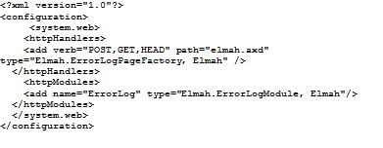

Register ELMAH's HTTP Modules and Handler in the <system.webServer> element. As before, if this element is not already present in your configuration then add it.

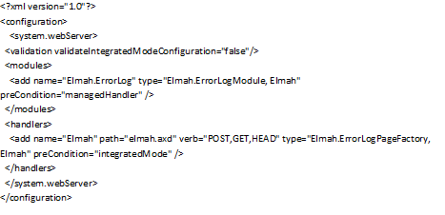

**Step 3: Configuring ELMAH**

ELMAH looks for its configuration options in the website's Web.config file in a custom configuration with name <elmah>. In order to use a custom section in Web.config it must first be defined in the <configSections> element. In Web.config file add the following markup to the 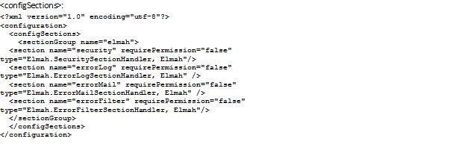

The above syntax registers the custom <elmah> section and its subsections: <security>, <errorLog>, <errorMail>, and <errorFilter>.Next, add the <elmah> section to Web.config. This section should appear at the same level as the <system.web> element. Inside the <elmah> section add anoter sections with name <security> and <errorLog> like so:

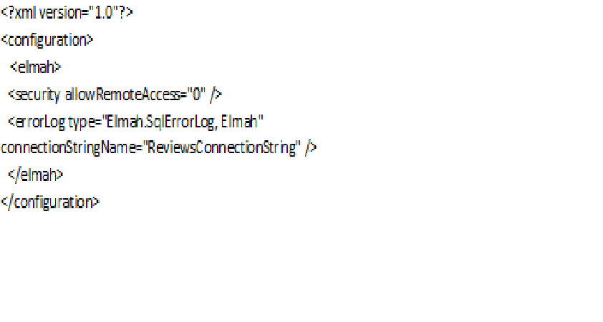

**Viewing the Error Details Page on Production**

After deploying your website to production, visit the production website and generate an unhandled exception. As in the development environment, ELMAH has no effect on the error page displayed when an unhandled exception occurs; instead, it merely logs the error.

Submitted By: Reviewed By:

Vishwadeepak Badoni Deepak Goyal

([badonivishwadeepak@seasiainfotech.com](mailto:badonivishwadeepak@seasiainfotech.com)) ([Goyaldeepak@seasiainfotech.com](mailto:Goyaldeepak@seasiainfotech.com))